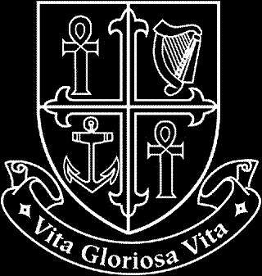
NATIONAL MATERNITY HOSPITAL

Human Resources Department

Vacancy

Antimicrobial Pharmacist (Senior)
Permanent and Fulltime

Applicants for this position should be registered on the Register of the Pharmaceutical Society of Ireland, or be entitled to be so registered. Experience of working in a hospital environment is essential. A minimum of at least 3 years post qualification hospital pharmacy experience is required.

Informal enquiries to David Fitzgerald, Chief Pharmacist (01-6376505 or dfitzgerald@nmh.ie)

Job description is available from - Ms Edel Mulligan, Human Resources Department (01-6373367 or emulligan@nmh.ie)

Interested candidates can email a cover letter and CV to emulligan@nmh.ie or alternatively can forward three copies of same with details of why they are suitable for the position, to Ms Edel Mulligan, The National Maternity Hospital, Human Resources Department, Holles Street Hospital, Dublin 2.

Closing date for applications: Wednesday 22nd May 2019.

