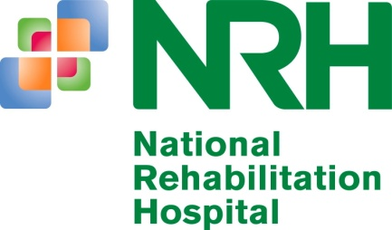

NATIONAL REHABILITATION HOSPITAL
Rochestown Ave, Dun Laoghaire, Co Dublin. Tel: (01) 235 5000

Applications are invited from suitably qualified persons for the following vacancy:

Permanent Pharmacy Technician

The National Rehabilitation Hospital is the National Centre for primary rehabilitation for adults and children, serving patients locally and from all over the country. The hospital includes the National Spinal Injury, Prosthetic, and Brain Injury Rehabilitation services and a Children’s Programme. The hospital also provides treatment for a wide variety of other conditions. The National Rehabilitation Hospital has been awarded a 3 year accreditation by CARF International which ranks the hospital as one of the leading rehabilitation facilities internationally. The National Rehabilitation Hospital is also currently undergoing rapid development and expansion of its rehabilitation services under the direction of Medical Consultants in Rehabilitation and Paediatrics.

We have an exciting opportunity for a dynamic and motivated pharmaceutical technician to join our pharmacy team.

Requirements:

The candidate must, on the latest date for receiving completed application forms for the office, possess:

(a) The Pharmaceutical Technicians Diploma/Higher certificate or an equivalent recognised Pharmaceutical technician qualification.

and

(b) Relevant hospital experience is desirable

Closing date for applications: Friday the 19th October 2018 at 5pm
Job Description requests and applications (by covering letter and Curriculum Vitae along with details of three referees) for the above post to: Ms. Eimear Foley Human Resources Department, or email eimear.foley@nrh.ie . For further information contact Sheena Cheyne, Chief Pharmacist or Claire Meaney, Senior Pharmacy technician on 01 235 5203.

Shortlisting may be carried out on the basis of the information supplied in your CV. The criteria for Shortlisting are based on the requirements of the post as outlined above. Failure to include information regarding these requirements may result in you not being called forward for the next stage of the selection process.

Panel of candidates may be formed for the above posts to provide for the filling of Permanent Pharmacy Technician vacancies that may arise in the near future.

We are an Equal Opportunities Employer and support a smoke-free workplace policy.

