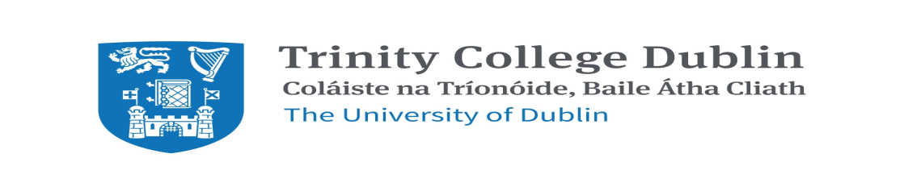
Applications are invited for the two-year (part-time) MSc in Hospital Pharmacy taught course, leading to a Master’s Degree in Hospital Pharmacy, commencing in January 2020.
Winner of the GradIreland Postgraduate Course of the Year in the Health Sciences Division 2019, the M.Sc. in Hospital Pharmacy is the longest running postgraduate hospital pharmacy course in Ireland. It is unique, in that it is the only broad-based hospital pharmacy course in Ireland, covering both clinical and non-clinical aspects of hospital pharmacy practice.
Key features of the course include the following:
* Provides students with expert knowledge and skills necessary to undertake all aspects of hospital pharmacy including clinical pharmacy, dispensary and drug distribution, administration and management, aseptic compounding, pharmacoeconomics and medicines information.
* Intensive practical experience is gained via the clinical and non-clinical rotations during the hospital attachment under the expert guidance of an assigned tutor(s).
* Face-to-face teaching sessions from clinical experts and hospital managers, who are leaders in their field.
* Opportunity for students to network with pharmacists from other Irish hospitals via small group and peer-review assignments at weekly teaching sessions during term time.

* Completion of a 20,000 word practice-based research project in either a clinical or non-clinical area, with support from both the School and a hospital-based tutor. Many students subsequently publish a paper based on their research.

Graduates of our M.Sc. programme have excellent job prospects and past graduates hold specialist and leadership roles across a wide range of both clinical and non-clinical areas in hospital practice throughout Ireland over the past 20 years.

Please see course webpage: http://www.pharmacy.tcd.ie/postgraduate/msc_hospital.php.
Closing date for applications: 30th June 2019.
Short-listed students will be invited to attend hospital interviews the week commencing 9th September 2019 to secure hospital placements. Successful applicants will be based in full-time employment in one of the course approved hospitals for the two-year duration of the course.

Further information may be obtained from:
Niamh McMahon, Course Coordinator, Ph.01-896 3181/416 2467
School of Pharmacy & Pharmaceutical Sciences,
Trinity College Dublin. Email: nmcmahon@tcd.ie

