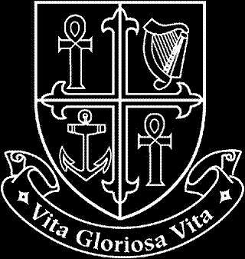
NATIONAL MATERNITY HOSPITAL

Human Resources Department

Vacancy

Senior Pharmacist
(Temporary Fulltime)

Applicants for this position should be registered on the Register of the Pharmaceutical Society of Ireland, or be entitled to be so registered. Experience of working in a hospital environment is essential.

Informal enquiries to David Fitzgerald, Chief Pharmacist (01-6376505 or dfitzgerald@nmh.ie)

A full job description is available from - Ms Edel Mulligan, Human Resources Department (01-6373367 or emulligan@nmh.ie)

Interested candidates can email a cover letter and CV to emulligan@nmh.ie or alternatively can forward three copies of same with details of why they are suitable for the position, to Ms Edel Mulligan, The National Maternity Hospital, Human Resources Department, Holles Street Hospital, Dublin 2.

Closing date for applications:

