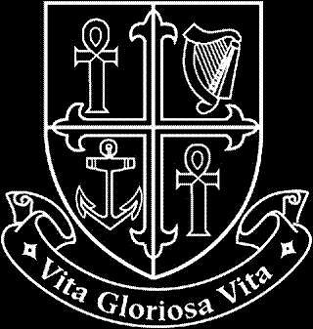
NATIONAL MATERNITY HOSPITAL

Human Resources Department

Vacancy

Senior Pharmacist
Fulltime - Specified Purpose Contract
(To cover Maternity Leave)

Applicants for this position should be registered on the Register of the Pharmaceutical Society of Ireland, or be entitled to be so registered. A minimum of at least 3 years post qualification experience is required.

Informal enquiries to David Fitzgerald, Chief Pharmacist (01-6373469 or david.fitzgerald@nmh.ie)

Interested candidates can email a cover letter and CV to emulligan@nmh.ie or alternatively can forward three copies of same with details of why they are suitable for the position, to Ms Edel Mulligan (01-6373367), The National Maternity Hospital, Human Resources Department, Holles Street Hospital, Dublin 2.

Closing date for applications: Monday 11th November 2019.

